**Drone, IoT, AI Based Forest Fire Extinguishing System.**

**Solution:**

Step1: Identify the forest to be setup this solution and make the A,B,C & D sections as below

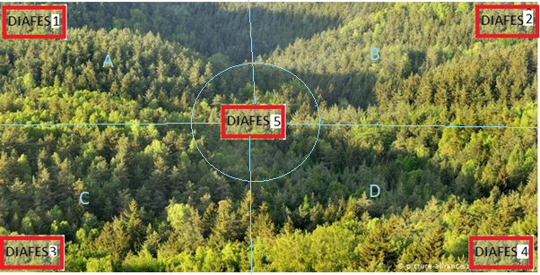

Step2: Divide the area of the forest into 5 and centre one you make as master one as below (DIAFES1,2,3,4,5)



Step3: Every DIAFES1 will be mounted and setup on each tower of 50 feet with High end drone with high quality camera on the top of all the cascaded flat square shaped box kind extinguishers (extinguisher1… extinguisher N) on spring coil at bottom to push each extinguisher is available for drone to pick up.

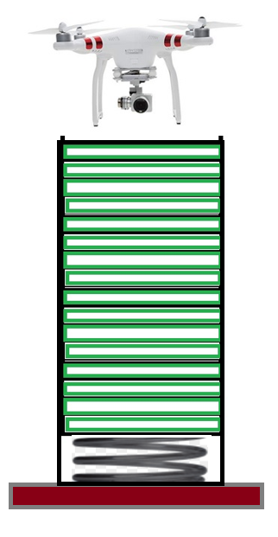

Base

Spring Coil

Drone with Camera

Extinguisher n

Extinguisher 2

Extinguisher 1

Step4: Every section of the forest will be placed with temperature sensors for every 10 feet distance and it’s location (x,y) details and it’s rearrest DIAFES system name will be captured in one of the master table ( Columnar Database) as below for quick and easy to read the data.

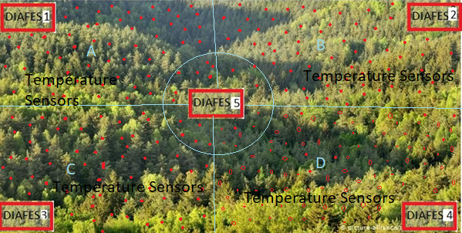

Step5: Once the temperature is breached the threshold temperature 40C from the temperature sensors then the respective DIAFES system will send drone to that fire place and cool and vanish the fire the Below TF Deep learning algorithm will be used to classify the image captured by the drones.

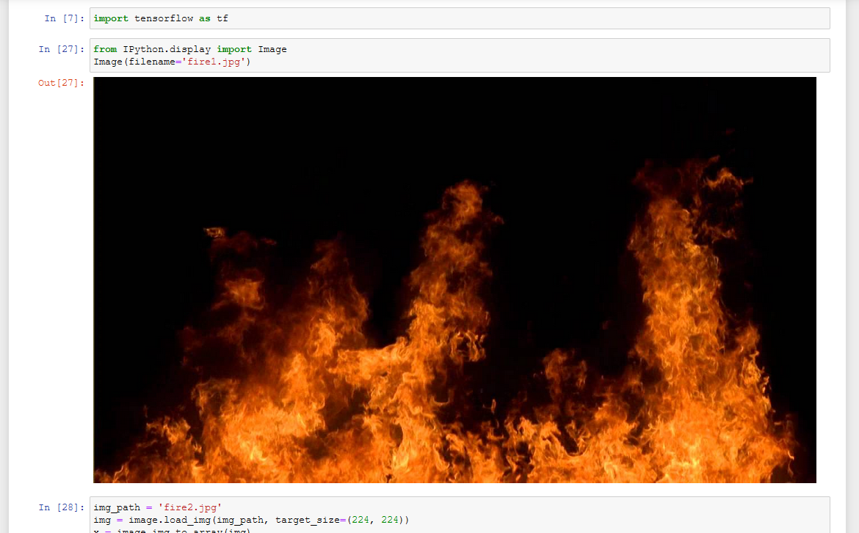

Note: world will have real time dashboard with all the insights, , Fore-sights & Recommendations.

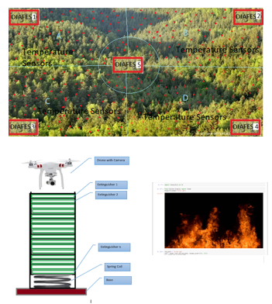

Deep Learning Code and Test Results



Image classification test results

